Aaron Banson

Prof. Bama

Advanced Programming in Java

December 03, 2020

Lab 12

Unauthorized:

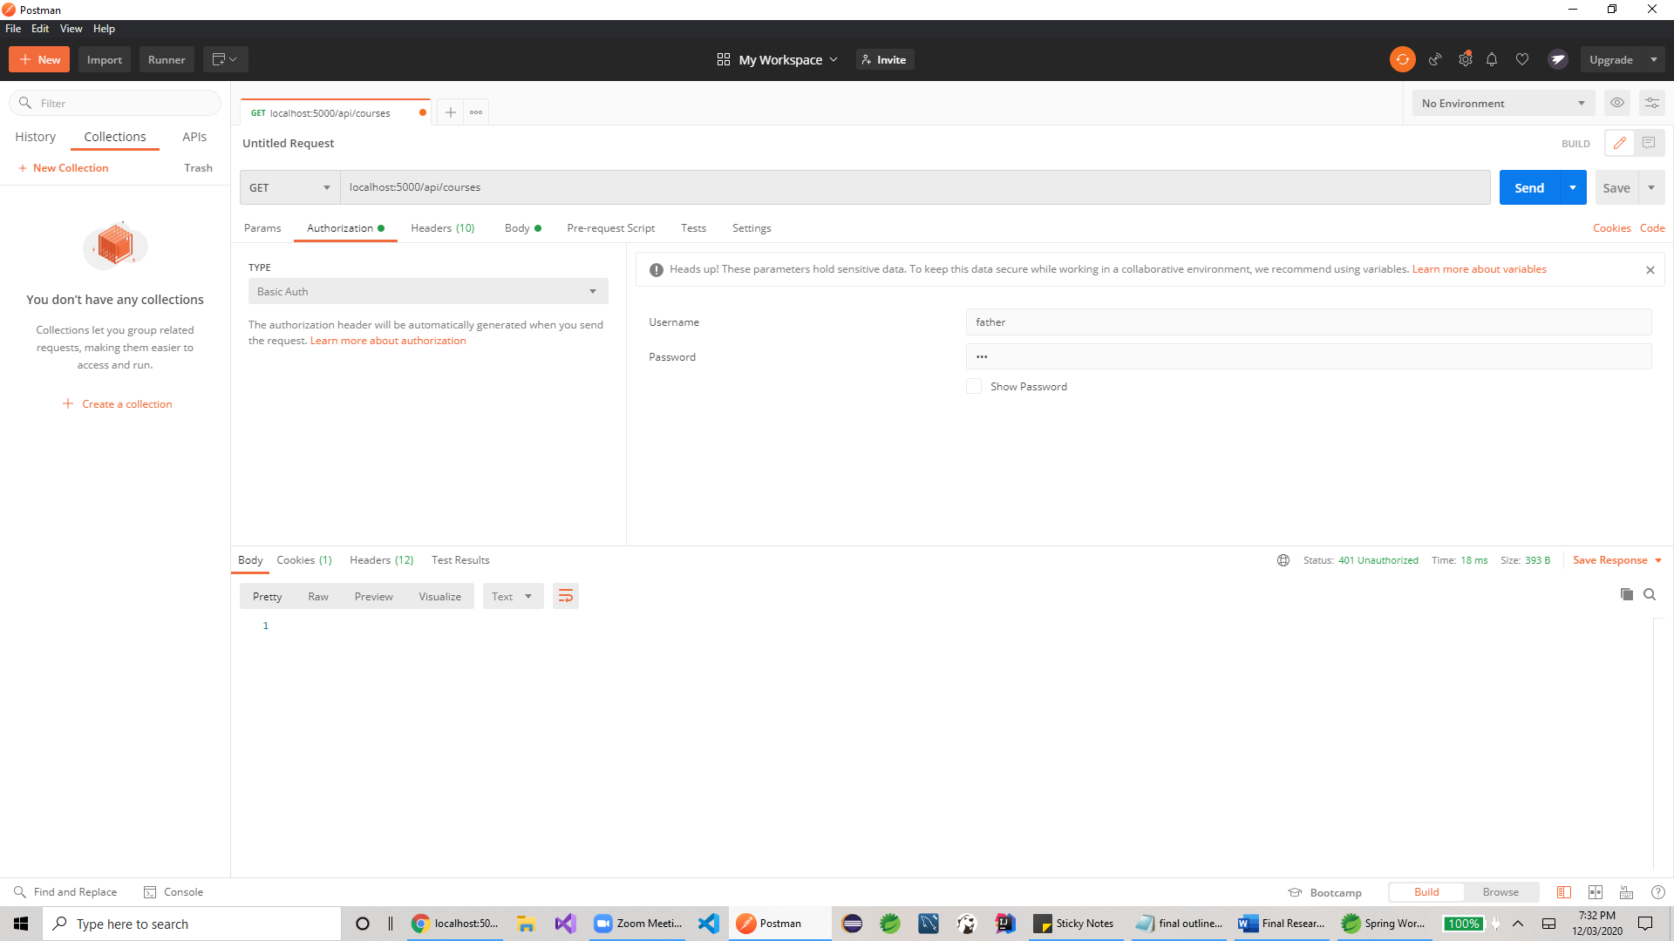

Authorized:

